**Linear regression Model**

**ACF and PACF plots before differencing** **the data**

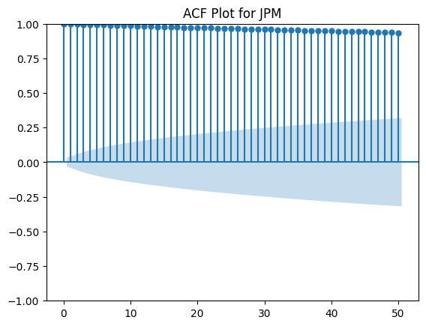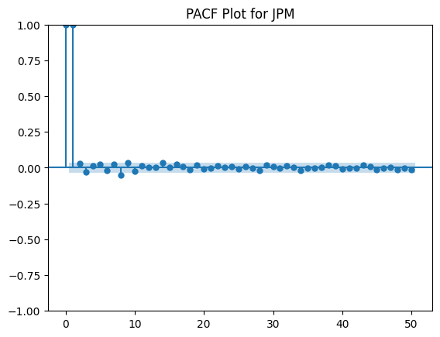**

**ACF and PACF plots after differencing** **the data**

**ACF and PACF plots after differencing** **the data**

v

**ARIMA model**

**ARIMA model**

**LSTM Model**

